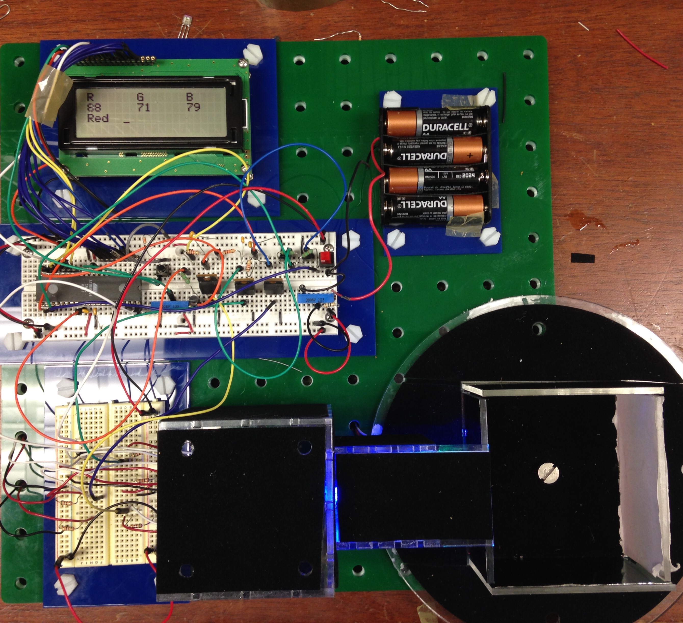

The system is a comprehensive color composition and light intensity detector. The horizontally positioned breadboard is central controlling circuit including microcontroller, low-pass filters, analog switches and ADCs. The system is assigned to function properly at 5V of DC input, which should be supposedly powered by DC regulated voltage input.

The black round-shape wheel on bottom right corner is presumed to be a reflector. The reflector has electric sensitive paper in red, green, blue and white on each side of the rectangular Acrylic screen. Once a certain input light is detected, the screen will immediately reflect the light back to a light sensor installed beneath the tunnel covered by black emery paper.

The vertically positioned breadboard and the Acrylic cube altogether function as light source combining a red, a green and a blue LED. By changing the intensity of each LED, we can generate all kinds of colors as different light sources. Each and every LED is connected to an ADC port on microcontroller to digitalize the light intensity making light altering much more accessible.

The LCD screen actually visualizes the color composition of the input light source by presenting numbers (0-255) of all three basic colors red, green and blue. The third line on LCD screen gives the most likely color of the reflecting screen, and, in this case, the screen is red.

We use USART port on microcontroller to transmit the data of color composition shown on LCD back to computer. The assumption of the most likely color of the reflecting screen is done by a software program, which is not shown in this picture. After processing the received data, the program will send the result back to microcontroller to give out the best guess. The accuracy is more than 97% meaning that the system is very reliable.